Table of Contents
0. Executive Summary Presentation 2
1. Organizational Interpretation of Results 3
1.0 Introduction 3
1.1 Translating Technical Results to Organizational Impact 4
1.2 Insights and Recommendations 7
1.3 Risk Assessment and Mitigation Strategies 17
2. Project Review and Reflection 19
2.1 Project Retrospective 19
2.2 Lessons Learned and Future Applications 23
3. Reference 25

Consumer Product Safety Analysis

Executive Summary Presentation

https://pitt.hosted.panopto.com/Panopto/Pages/Viewer.aspx?id=120a1689-b885-4e8c-930a-b4320031698a

Organizational Interpretation of Results

1.0 Introduction
The Consumer Safety Research Institute (CSRI) is a specialized fictional nonprofit organization established in 2012 to perform independent research on consumer product safety and publish reports and insights that defines public disclosure, and aids in policy decisions. The domain of consumer product safety is currently characterized by a significant disconnect between available data and public understanding. the prevailing public discourse frequently relies on anecdotal evidence, high-profile media incidents, or biased manufacturer marketing rather than systematic, empirical analysis. This reliance on incomplete information leaves consumers, policymakers, and safety advocates without the evidence-based insights necessary for informed decision-making. This information gap creates a critical challenge in an environment where stakeholders increasingly demand rigorous, independent verification to distinguish between isolated accidents and genuine systemic risks. There is a pressing market need for an authoritative intermediary capable of translating dense surveillance data into clear, actionable intelligence.
The primary objective of the project is to develop predictive models to identify which consumer product injuries are most likely to result in hospitalization and determine what factors—product categories, demographics, injury characteristics—predict severe medical outcomes among emergency department cases, producing evidence-based findings that inform CSRI's 2025 Product Safety Spotlight report and contribute to public understanding of consumer product safety priorities. The secondary objective of the project is to Identify temporal and demographic trends in consumer product injury severity patterns, including seasonal variations, changes over time, and emerging patterns that may indicate shifting safety concerns, generate insights about demographic patterns in severe product injuries that inform targeted safety messaging, and create analytical approaches that enhance CSRI's reputation as a leading source of independent consumer safety research.
Primary data science goal is to establish statistically significant correlations between factors contributing to physical injuries and hospitalization due to the use of consumer products with a high degree of confidence; secondary goal is to create interpretable models that quantify effect sizes for public communication. This dataset description document will explain in detail the datasets used for the modelling and any major analysis work of the project.

1.1 Translating Technical Results to Organizational Impact

1.1.1 Performance Interpretation
Model performance was evaluated utilizing PR-AUC and MCC metrics to ensure robustness on highly imbalanced data.
Estimator | MCC Score | PR-AUC Score | Primary Strength
Decision Tree | 0.432 (Best) | 0.54 | Balanced classification at default threshold.
XGBoost | 0.413 | 0.55 (Best) | Superior ranking and probabilistic separation.
Random Forest | 0.353 | 0.44 | Moderate performance; likely underperforming on rare classes.
Logistic Regression | 0.346 | 0.48 | Baseline performance; captures linear trends only.

The Decision Tree was selected as the Primary Model because it achieved the highest MCC score, demonstrating superior balanced classification at the standard 0.50 operational threshold. Crucially, it provides the high interpretability required to translate mathematical findings into actionable safety recommendations. XGBoost was designated as the Secondary Model. While XGBoost delivered the highest overall PR-AUC—indicating strong general capability in ranking high-risk versus low-risk cases across all thresholds—its 'black box' architecture limits transparency. Furthermore, at the specific 0.50 operational cutoff, XGBoost generated more 'near miss ‘ classification errors (false positives and false negatives), which penalized its MCC score relative to the Decision Tree.

Expected Organizational Outputs
Achieving an MCC score of 0.432, the predictive model demonstrates a reliable capability to identify the primary factors contributing to severe product-related injuries and hospitalizations. The model successfully isolates high-risk product categories and highlights critical demographic vulnerabilities. Armed with these statistically robust findings, CSRI can publish evidence-based insights—such as the 2025 Product Safety Spotlight report—that elevate public discourse. Ultimately, this output will help shape local policy discussions, inform manufacturer safety standards, and empower consumers to make data-backed decisions regarding consumer product safety.

Confidence Levels
The MCC of 0.43 that we got for the Decision Tree estimator reflects a deliberate, optimized trade-off between Precision and Recall. Given the business objective of identifying high-severity injuries, the threshold was calibrated to prioritize capturing True Positives (actual severe injuries), accepting a corresponding increase in False Positives. This trade-off prevents the metric from reaching the upper bounds but strictly aligns with our risk-mitigation goals. Because the model exhibits a moderate predictive correlation, deployment strategies must account for a known margin of predictive error. The algorithm should not be utilized as an autonomous, definitive classifier for product recalls. Instead, it must be deployed as a 'prioritization engine' to flag high-risk product categories and vulnerable demographics for further human-in-the-loop review by safety analysts.

Value Proposition
Publishing this consumer product safety spotlight report would cost approximately 60-100 hours of editorial time but could establish the publication's credibility in data-driven reporting, potentially attracting new readers interested in evidence-based local journalism and demonstrating the organization's commitment to public service reporting.

1.2 Insights and Recommendations

1.2.1 Key Findings

1.2.1.1 Number of Hospitalizations by Age-group and Gender
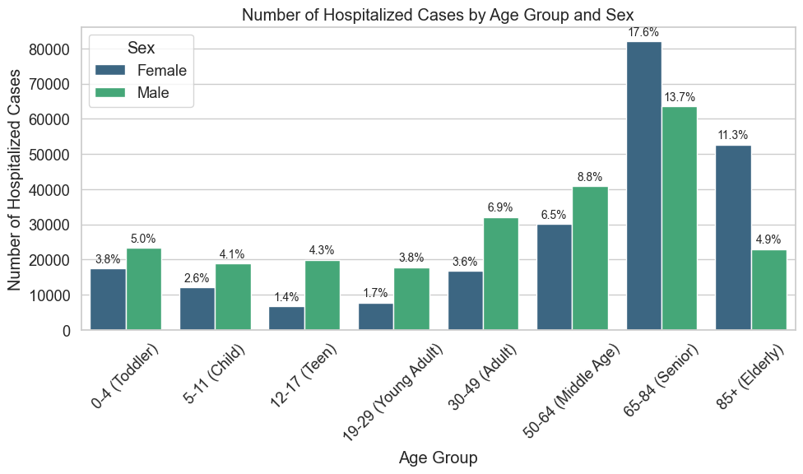
When evaluating injury severity, the data reveals the highest frequency of hospitalizations occurs among patients aged 65 and older, skewing heavily female. This is followed by the 50-64 age bracket, which demonstrates a secondary peak in severe outcomes but with a predominantly male incidence.

1.2.1.2 Injury Seviarity Across Product Categories

Injury Count Across Products
Exploratory data analysis (EDA) revealed a heavy concentration of injury volume within structural household categories. Specifically, 'Stairs or steps' account for the highest absolute frequency of reported incidents, followed closely by 'Floors or flooring materials' and 'Beds or bedframes'.

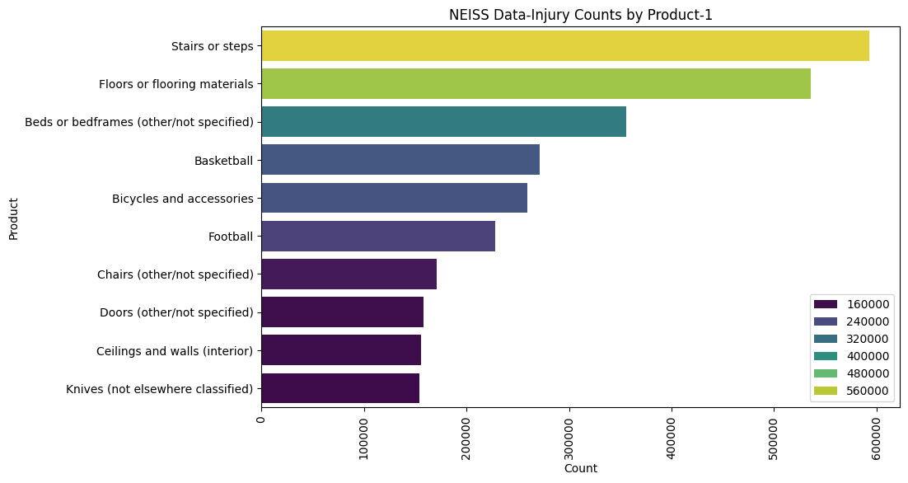

Injury Rate by Product Category and Age Group

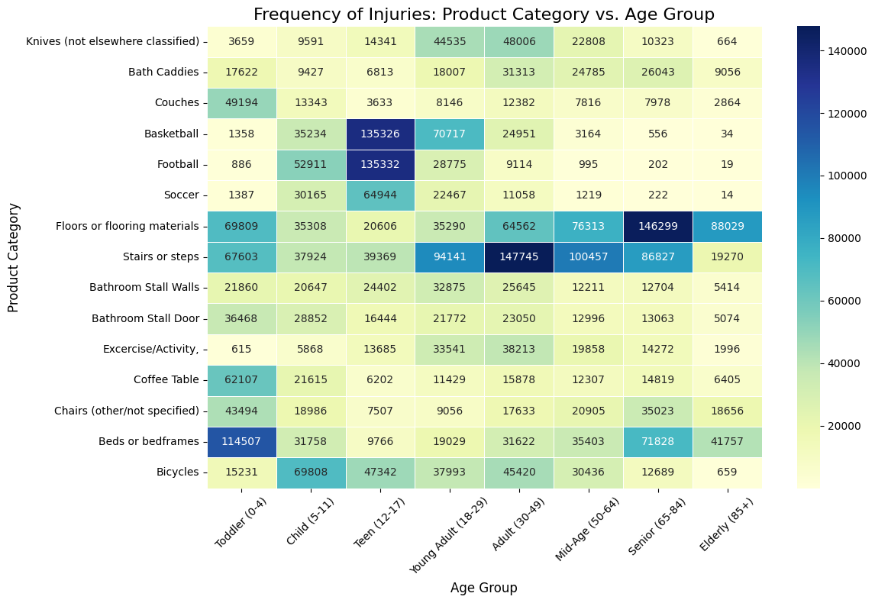
The heatmap reveals several severe concentrations of injury frequencies (represented by the dark blue cells) across the intersection of Product Category and Age Group.
- Infants & Toddlers (0-4): Injuries in this demographic are dominated by household furniture, with Beds or bedframes accounting for the highest frequency (114,507 incidents), followed by Floors (69,809) and Coffee Tables (62,107).
- Adolescents (Teens 12-17): There is a massive spike in sports-related injuries during the teenage years. Football (135,332) and Basketball (135,326) represent two of the most concentrated injury pockets in the entire dataset. Bicycles also remain a persistent hazard, peaking earlier in the Child (5-11) demographic with 69,808 injuries.
- Adults (30-49): Structural household hazards overtake sports and furniture. Stairs or steps constitute the absolute peak injury volume for this age bracket with 147,745 incidents.
- Seniors (65-84) & Elderly (85+): Environmental fall hazards become the overwhelming driver of injuries. Floors or flooring materials account for 146,299 injuries among Seniors and remain the leading hazard for the Elderly (88,029 incidents), highlighting severe vulnerability to basic structural environments as patients age.

Hospitalization Rate by Product Category and Age Group
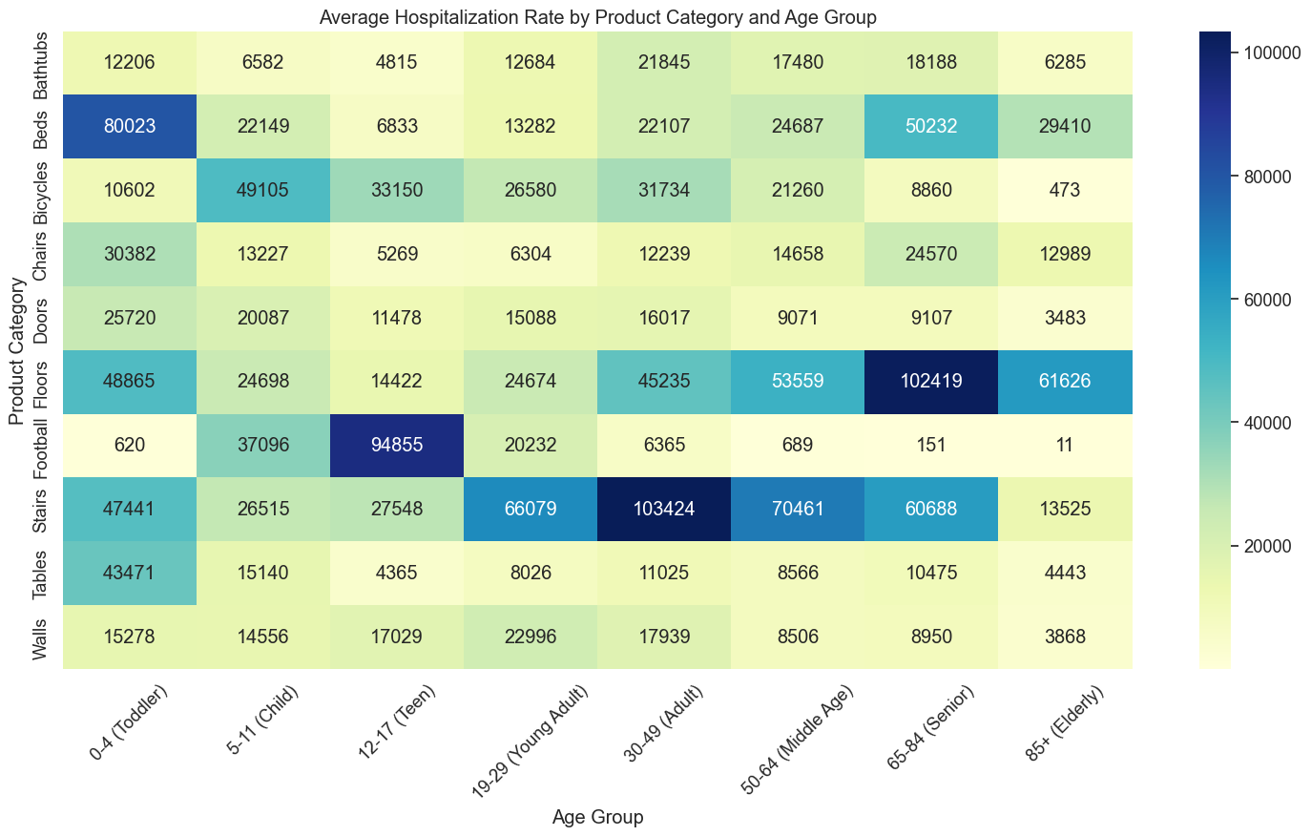

The visualization highlights several severe concentrations of injury volumes (represented by the dark blue cells) at the intersection of Product Category and Age Group.
- Toddlers (0-4): Injuries in this demographic are heavily dominated by Beds, which account for a massive 80,023 incidents—the highest volume for any product in this age bracket by a wide margin.
- Children & Teens (5-17): Hazards shift dramatically toward sports and outdoor activities. Bicycles peak during the 5-11 (Child) years with 49,105 incidents. During the 12-17 (Teen) years, Football becomes the most significant danger, causing an extreme spike of 94,855 incidents.
- Adults (19-64): Structural household hazards become the primary driver of injuries. Stairs consistently cause high volumes across all adult groups, peaking violently in the 30-49 (Adult) demographic with 103,424 incidents—the highest single cell value in the entire dataset.
- Seniors (65-84) & Elderly (85+): Environmental fall hazards overtake all other categories. Floors account for 102,419 incidents among Seniors (65-84) and remain the leading hazard for the Elderly (85+) with 61,626 incidents.

1.2.1.3 Injury Mechanisms Product Vs Diagnosis
The heatmap exposes several distinct, high-volume injury patterns (represented by the dark blue and heavy teal cells) at the intersection of Consumer Product and Medical Diagnosis:
- Structural Fall Hazards (Stairs & Floors): These categories drive the most severe and highest-volume blunt force traumas.
- Stairs/Steps are the leading cause of Strains/Sprains in the entire dataset (143,102 incidents), as well as massive volumes of Fractures (116,025) and Contusions/Abrasions (100,311).
- Floors/Flooring represent the highest driver for Internal Injuries (108,940 incidents), while also being a massive source of Fractures (98,973) and Contusions/Abrasions (98,594).
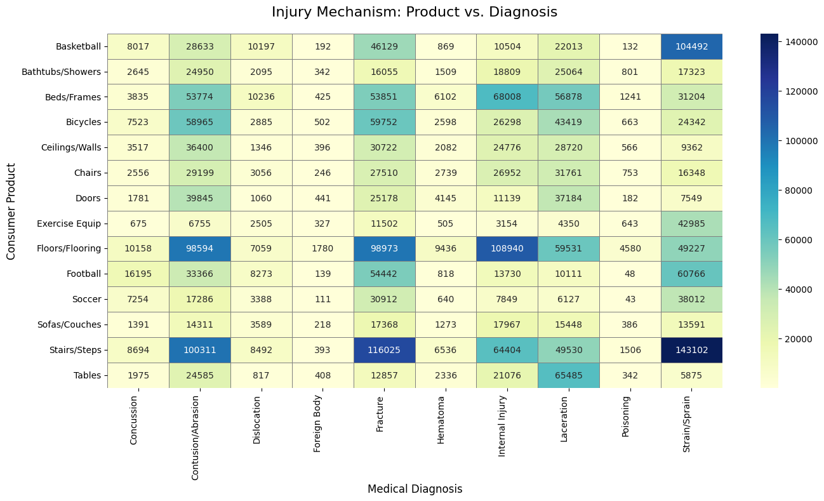
- Sports Equipment: Injury mechanisms here are overwhelmingly joint and muscle related. Basketball has a massive, isolated spike in Strains/Sprains (104,492 incidents), with Football showing a similar but less concentrated pattern (60,766 Strains/Sprains).
- Furniture: Different types of furniture cause distinct injury types. While Beds/Frames are highly associated with Internal Injuries (68,008) and Lacerations (56,878)—likely from falling out of bed or hitting the frame—Tables show a very specific, isolated spike in Lacerations (65,485), suggesting edge-impact injuries.

1.2.1.4 Injury Trends

Annual Trends
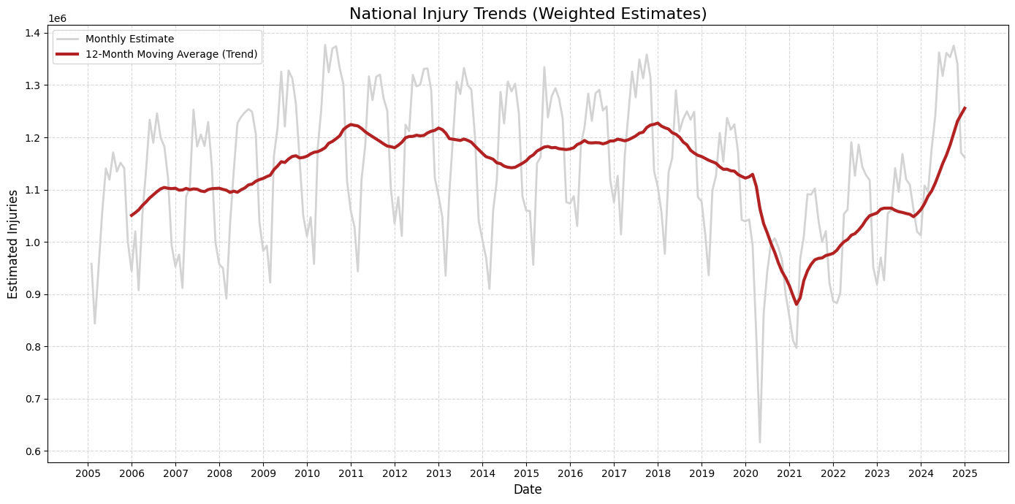

The raw monthly estimates demonstrate a severe, consistent cyclical pattern, confirming strong, predictable seasonal variations in product-related injuries year over year. Historically, the 12-month moving average indicates a gradual increase in total injuries from 2005 to roughly 2011, followed by a relatively stable plateau through 2019. The most striking anomaly is the unprecedented collapse in injury volume occurring in early 2020, perfectly aligning with the onset of the COVID-19 pandemic and widespread lockdowns. Following this historic drop, the data shows a steep, sustained recovery phase beginning in 2021. By 2025, the national injury trend has not only recovered but has accelerated past pre-pandemic levels to reach new two-decade highs.

Seasonal Trends
Injury volumes consistently reach their lowest median point in February before initiating a steady, sharp climb throughout the spring. The data reveals a distinct "danger season" spanning from May through September, where monthly injury estimates consistently peak between 1.2 and 1.3 million incidents.

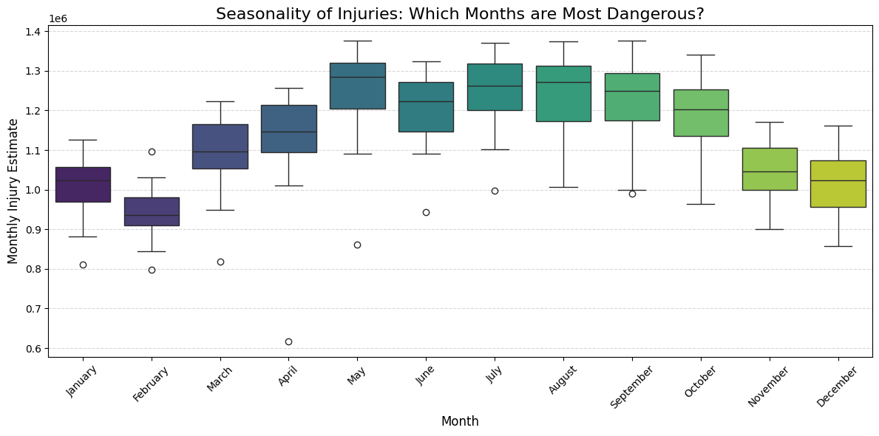
During this peak summer window, the interquartile ranges remain highly elevated, indicating that these high injury volumes are a reliable, structural expectation year over year. Conversely, several extreme low outliers are explicitly visible below the whiskers across the spring and summer months, most notably dropping near 0.6 million in April.

1.2.1.5 Product Risk Matrix
The scatter plot reveals a crucial segmentation, most notably identifying a "Primary Target" quadrant characterized by both high annual injury volume and severe hospitalization rates. "Floors" and "Beds" dominate this critical zone, proving that standard household elements represent the most consistent severe hazards to consumers.
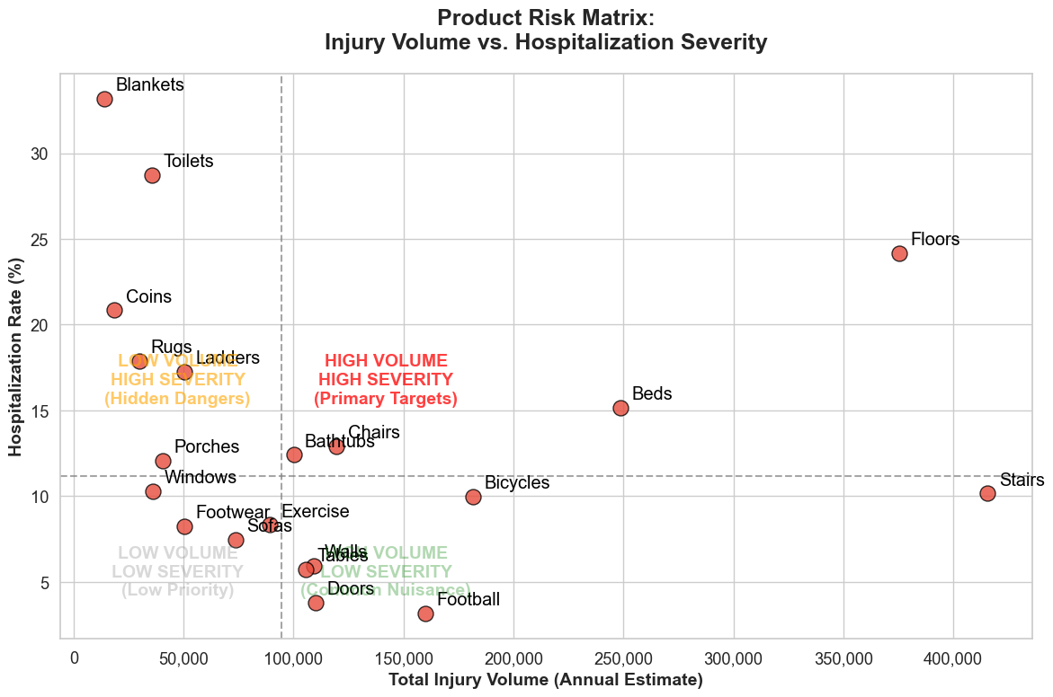

Conversely, the top-left quadrant exposes a fascinating cluster of "Hidden Dangers," such as "Blankets" and "Toilets," which trigger relatively few total injuries but result in exceptionally high hospitalization rates exceeding 25%. On the opposite end of the spectrum, high-volume items like "Football" and "Doors" fall into the "Common Nuisance" category, generating massive incident counts but extremely low severity rates. Finally, the bottom-left quadrant identifies "Low Priority" hazards, such as "Sofas" and "Footwear," which register below the median on both frequency and hospitalization metrics.

1.2.2 Strategic Recommendations

1.2.2.1 Focus safety messaging
To translate our data insights into an actionable deployment strategy, I recommend initiating targeted safety messaging campaigns. First, interventions must prioritize the 65-and-older demographic to increase risk awareness, as this group exhibits the highest hospitalization frequency. Secondly, deployment should include public education initiatives highlighting the dangers associated with high-risk consumer products identified in the model, notably stairs, toilets, rugs, ladders, coins, and blankets.

1.2.2.2 Execute safety campaigns
To translate the model's insights into an actionable Deployment strategy, interventions must be timed to align with seasonal risk trends. Because the data indicates that injury volumes consistently peak at 1.2 to 1.3 million monthly incidents from May through September, deployment efforts must prioritize this timeframe. I recommend scheduling targeted safety campaigns to coincide directly with this identified high-risk season to maximize preventative impact.

Recommend product design improvements
To address our core objectives regarding risk mitigation, the analytical findings must directly influence future product development. Because the evaluation identified blankets, toilets, rugs, ladders, and stairs as high-severity variables, I recommend prioritizing these categories for engineering redesigns. Integrating enhanced safety features into future builds will translate our data insights into tangible consumer protection.

Develop Age specific guidelines
To effectively translate model insights into public safety improvements, our Deployment strategy mandates the creation of demographic-specific safety campaigns. By designing specialized guidance for the vulnerable populations identified in the data (specifically seniors and young children), we can optimize public awareness and foster safer consumer handling of targeted products.

Feature Importance Interpretation
The XGBoost model identified diagnosis type and body part affected as the strongest predictors of hospitalization.
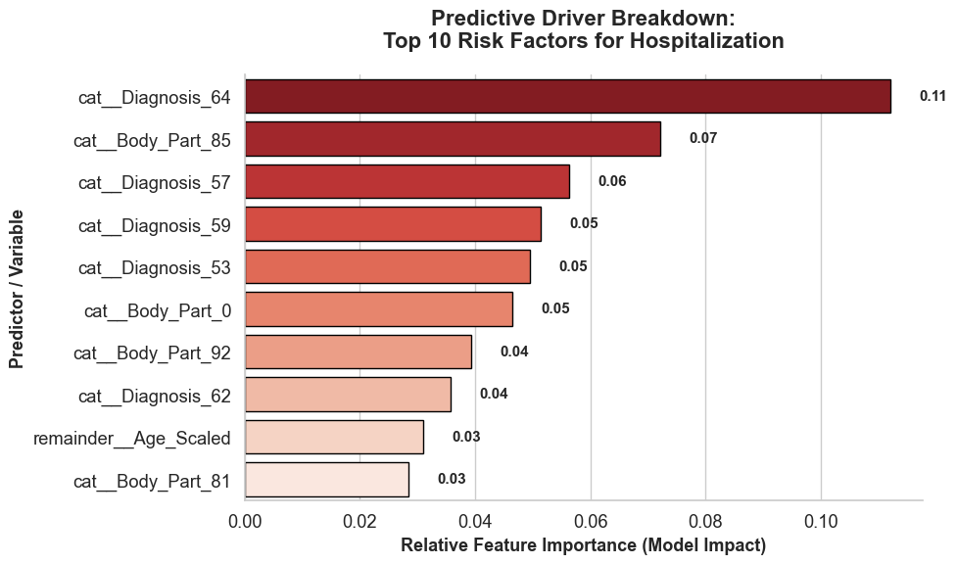
These features should guide clinical assessment and intervention strategies.

Limitations and caveats
NEISS exclusively captures injuries treated in US hospital emergency departments. The dataset inherently suffers from severity bias. It completely misses minor injuries treated at home, at primary care physicians, or in urgent care clinics, as well as fatal injuries where the patient died before reaching the hospital. NEISS records indicate that a consumer product was involved in an incident, not necessarily that the product caused the injury. NEISS is a stratified probability sample of roughly 100 hospitals, not a universal census. While national estimates (like the 1.2 to 1.3 million peak summer incidents) are generated using statistical weights, they carry an inherent margin of error.

1.3 Risk Assessment and Mitigation Strategies

1.3.1 Model Risks
The Evaluation of the final model highlights two critical caveats regarding its real-world application. The algorithm may underperform when encountering out-of-vocabulary data, such as new products requiring novel classifications (e.g., electric scooters). Furthermore, because the model identifies statistical correlations rather than definitive causality, it may erroneously associate hospitalizations with completely safe products that were involved in an event but did not act as the root cause of the injury.

Data Risks
If the data collection process changes and if certain fields start having more missing values – like narrative feature or diagnosis or product the model’s accuracy could drop below the acceptable thresholds.

Organizational Risks
A critical component of our objectives is defining the operational and legal boundaries of our public reporting. The final deployment strategy must strike a precise statistical balance: exaggerating safety conclusions risks severe reputational damage and manufacturer lawsuits, while minimizing real product-related risks fails to encourage necessary protective behaviors, directly endangering the public

Ethical Considerations
A critical ethical consideration governing this project is the socioeconomic bias embedded within the source data. By relying exclusively on Emergency Department visits, the dataset inherently underrepresents uninsured and lower-income populations who often avoid hospital-based care due to associated costs. To ensure equitable public safety reporting, our conclusions must transparently account for this disparity, acknowledging that the model is statistically predisposed to underestimate the true hazard levels of consumer products predominantly used by underinsured communities.

Mitigation Approaches
To ensure the integrity of the Deployment phase, all model outputs and subsequent safety messaging must be governed by a strict operational framework. This requires mandating rigorous peer review for all published conclusions and embedding explicit uncertainty quantification (such as 95% confidence intervals) directly into the public reporting. Furthermore, the deployment strategy must include tailored community engagement protocols to accurately communicate these risk boundaries to the public, supported by formalized correction and retraction procedures to address any post-publication anomalies.

Project Review and Reflection

2.1 Project Retrospective

2.1.1 What went well

2.1.1.1 Data Extraction
Initial data collection proved highly efficient. During the Data Preparation phase, annual records were extracted from the NEISS portal in CSV format and systematically concatenated to construct a single, unified dataset. To establish the framework for the subsequent Modeling phase, this integrated dataset was partitioned into a 70:15:15 split, designating subsets for training, testing, and holdout evaluation, respectively.

2.1.1.2 Understanding the Data
During the Data Understanding phase, exploring and comprehending the dataset was highly straightforward due to robust external documentation. The comprehensive resources provided on the CPSC portal—specifically the data dictionary (National Institute of Environmental Health Sciences. (n.d.).), the NEISS Coding manual, and the comparability table (U.S. Consumer Product Safety Commission. (2018))—served as critical references for extensively interpreting the data schema and variable definitions.

2.1.1.3 Gaining Business Understanding
During the Business Understanding phase, exploring and comprehending the business requirement was highly straightforward due to robust external documentation. The comprehensive resources provided on the CPSC portal—specifically the data dictionary(National Institute of Environmental Health Sciences. (n.d.).), the NEISS Coding manual (NEISS Coding Manual January 2025(Rev.1). (n.d.).,) and the comparability table—served as critical references for extensively interpreting the data schema and variable definitions.

2.1.1.4 Challenges Faced

High Class Imbalance
The data downloaded from the NEISS portal was inherently highly imbalanced in the ratio 9:1 (minority class to majority class) . A 9:1 class imbalance introduces fundamental challenges in predictive modeling, primarily because most standard machine learning algorithms are optimized to minimize overall global error. When 90% of the data belongs to a single class, the model is mathematically incentivized to prioritize the majority, often at the complete expense of the minority class.

Huge Data Volume
Processing a dataset of 7 million records (approximately 1GB) fundamentally shifts the operational focus of the Data Preparation and Modeling phases from basic functionality to strict computational efficiency. During Data Preparation, this volume requires careful memory management and the exclusive use of vectorized operations, as inefficient code can quickly balloon memory usage and create debilitating Input/Output bottlenecks that overwhelm standard hardware.
Moving into the Modeling phase, the sheer scale of the data renders time-complex algorithms—like standard SVMs or K-Nearest Neighbors—virtually unusable and makes extensive hyperparameter tuning prohibitively expensive, forcing a reliance on highly scalable tree-based or linear models.

High Feature Cardinality
The presence of high-cardinality categorical variables—such as a feature containing 750 distinct product codes—introduces critical complexities that heavily impact both the Data Preparation and Modeling phases. During Data Preparation, naive transformations like one-hot encoding needs be strictly avoided, as they trigger a massive expansion of the feature space (the "curse of dimensionality"), which drastically increases memory consumption and computational overhead. This forced me to implement more sophisticated Target encoding to condense the categorical information without losing its signal.

Harmonizing Product Taxonomy Changes
During the Data Preparation phase, the harmonization of shifting product taxonomies is a critical dependency for ensuring structural and historical consistency across the dataset. Because longitudinal data often contains evolving classification codes, deprecated categories, or fragmented sub-tiers, failing to map these disparate entries into a unified standard artificially fractures the underlying data signal and creates unnecessary sparsity.

Alternative Approaches
In evaluating alternative approaches for the Modeling and Data Preparation phases, transitioning from the current Scikit-learn architecture to an Apache Spark MLlib pipeline framework presents a highly viable strategy for managing high data volumes. While Scikit-learn is highly effective, its strict reliance on single-node, in-memory computation introduces distinct memory and processing bottlenecks when applied to a dataset of 7 million records. Implementing Spark MLlib would allow the project to leverage distributed cluster computing, natively handling the massive size and volume of the data through parallel processing. This architectural shift would significantly accelerate both feature engineering and hyperparameter tuning, providing a more robust, scalable foundation for future deployments.

CRISP-DM Reflection
While the CRISP-DM methodology provided a robust and systematic framework for this investigation, its inherently corporate terminology necessitated some adaptation to align with our specific research objectives. Most notably, the final 'Deployment' phase was recontextualized; rather than operationalizing a predictive model in a production environment, deployment in this context focused on the publication and dissemination of the Product Safety Spotlight findings.

Time Allocation
An analysis of the project timeline reveals a strong emphasis on foundational data engineering and rigorous model validation. The Data Preparation phase required the largest allocation of resources (60%), reflecting the necessary complexities of cleaning, mapping, and engineering features for high-volume data. The Modeling phase accounted for 15% of the timeline, closely followed by a dedicated 10% allocation for Model Evaluation, ensuring the final algorithm reliably met business objectives before moving forward. The scoping and operational phases—Business Understanding (5%), Data Understanding (5%), and Model Deployment (5%)—were executed highly efficiently, making up the remaining 15% of the project.

2.2 Lessons Learned and Future Applications

Technical Lessons
      - Identifying Data Inconsistencies
      - Handing Product Taxonomy Changes
      - Target Encoding in pace of One-Hot Encoding
      - Stratified Splitting
      - Measure Model Performance

Process Insights
      - Setting up python environments
      - Version control through GitHub
      - Setting up pipelines to run models

Domain Knowledge
The project facilitated a comprehensive Data Understanding of consumer product interaction across diverse demographic segments, highlighting the inherent complexity of modeling injury severity. This investigation provided critical insights into the scientific foundations of the NEISS data collection standards and established a data-driven baseline for injury classification. Furthermore, the Evaluation phase isolated several high-impact variables—specifically seasonal trends, demographic vulnerabilities, and diagnosis types—that act as statistically significant drivers of hospitalizations and high-severity outcomes.

Tool Proficiency
Throughout the Data Preparation and Modeling phases, the project utilized a rigorous DevOps approach to ensure analytical reproducibility. Proficiency was gained in architecting scikit-learn pipelines, which streamlined the transition from feature engineering to model training. The environment was managed using the UV package manager for high-performance dependency isolation, while Git was implemented for comprehensive version control. Furthermore, advanced pandas’ techniques were leveraged for complex data manipulations, ensuring the structural integrity of the 7-million-record dataset prior to modeling.

Future Applications
The Data Preparation and Feature Engineering strategies developed for this project are highly transferable and can be adapted to any domain-agnostic behavioral prediction problem. Furthermore, the robust Evaluation framework—designed specifically to address the nuances of a 9:1 class imbalance—provides a standardized methodology for any classification task where minority class recall is a critical success criterion. This ensures that the analytical pipeline remains an asset for future business objectives beyond consumer product safety.

Reference

U.S. Consumer Product Safety Commission. (2018). 2018 comparability table [PDF]. https://www.cpsc.gov/s3fs-public/2018ComparabilityTable.pdf?fl8xxa40fZ0nmn3r43sKCVuI7JN4cGMV
NEISS Coding Manual January 2025(Rev.1). (n.d.). https://www.cpsc.gov/s3fspublic/JANUARY-2025-NEISS-CPSC-only-Coding-Manual-Rev-1.pdf?VersionId=RxQ0jRb8mHK.z2CrX2iG385fkC8sZjnm
National Institute of Environmental Health Sciences. (n.d.). NIEHS data dictionary. U.S. Department of Health and Human Services, National Institutes of Health. https://www.niehs.nih.gov/research/resources/datadictionary/

